Project Design Phase-II
Data Flow Diagram & User Stories

Date | 30 September 2026
Team ID | SN-TRANSFORM-01
Project Name | Import Data using Transform Maps (Spreadsheet)
Maximum Marks | 4 Marks

Data Flow Diagrams:
This project uses data-flow views to show how employee spreadsheet rows move through ServiceNow staging, transformation, validation and reporting. The diagrams identify the source, processing steps, data stores and outputs.

ServiceNow Employee Import Data Flow
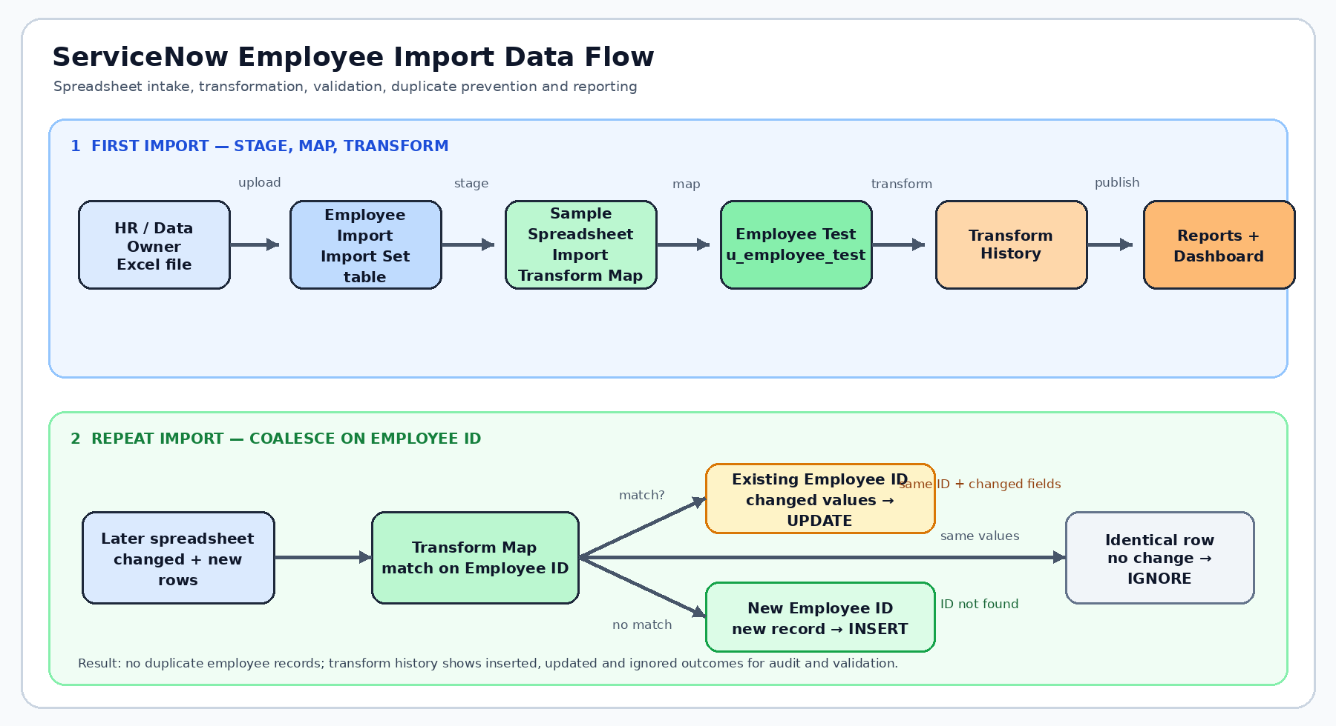
User Stories – Employee Spreadsheet Import
The user stories below translate the project workflow into testable administrator, HR and data-quality outcomes.
User Type | Functional Requirement (Epic) | User Story Number | User Story / Task | Acceptance criteria | Priority | Release
ServiceNow Administrator | Spreadsheet Intake | USN-1 | As an administrator, I can load Sample Spreadsheet.xlsx into Employee Import. | Import Set is created with the expected header and row count. | High | Sprint-1
ServiceNow Administrator | Target Table | USN-2 | As an administrator, I can create Employee Test with the five required string fields. | Employee ID, Name, Email, Department and Location are visible. | High | Sprint-1
ServiceNow Administrator | Transform Map | USN-3 | As an administrator, I can create Sample Spreadsheet Import from Employee Import to Employee Test. | Source and target tables are selected and saved. | High | Sprint-1
ServiceNow Administrator | Field Mapping | USN-4 | As an administrator, I can auto-map and review field mappings before transforming. | All five fields are mapped correctly and reviewable. | High | Sprint-1
HR / Data Owner | Data Validation | USN-5 | As a data owner, I can confirm imported employee values in Employee Test. | Records contain the expected IDs, names, emails, departments and locations. | High | Sprint-1
ServiceNow Administrator | Coalesce | USN-6 | As an administrator, I can set Coalesce on Employee ID. | A matching ID is treated as an existing record rather than a duplicate. | High | Sprint-1
HR / Data Owner | Recurring Import | USN-7 | As a data owner, I can load a later file with changed values and new IDs. | Changed existing IDs update and new IDs insert. | High | Sprint-2
ServiceNow Administrator | Transform History | USN-8 | As an administrator, I can inspect transform history after each run. | Inserted, updated, ignored and error outcomes are visible. | High | Sprint-2
ServiceNow Administrator | Repeatability | USN-9 | As an administrator, I can repeat the same file without creating duplicates. | Identical rows are ignored or show no-change outcomes. | High | Sprint-2
HR / Data Owner | Department Report | USN-10 | As an HR user, I can view Employees by Department as a pie chart. | The report counts records grouped by Department. | Medium | Sprint-3
HR / Data Owner | Location Report | USN-11 | As an HR user, I can view Employees by Location as a bar chart. | The report counts records grouped by Location. | Medium | Sprint-3
ServiceNow Administrator | Analytics Dashboard | USN-12 | As an administrator, I can add the three employee reports to Employee Analytics Dashboard. | Department, location and list reports appear together. | Medium | Sprint-3

